**Star - Sanei SK1-31s ATM printer**

Table of Contents

1. **Troubleshooting summary and hotfixes2**
2. **Printer settings3**
3. **XML settings7**
4. **Troubleshooting and hotfixes:**

**!!Most common issue: Printer will show paper issue!!**

**Fix: go to Printer properties and untick “Enable bidirectional support”**

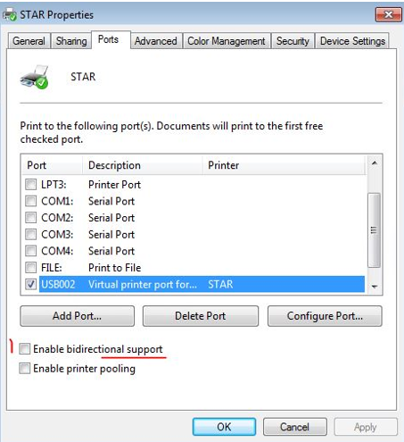

**If this is not the case continue with troublehooting:**

1. **Is the printer being detected in “devices and printers”**
2. **Printer is detected and shows green tick sign-**

Continue troubleshooting- go to 2nd step of this guide

1. **Printer shows as “unknown device”-**

-Solution: ask cinema reset the cables, try to plug printer to another USB port on ATM’s PC.

If this does not help- replace printer via SCC

1. **Printer is being detected however it has a warning status:**

Solution: Apply fix accordingly to issue displayed on the printer. Most common issue is paper jamming due to wrong settings (check 2. *Printer settings* part of this guide.)

1. **What happens when running “test print”:**
2. **Printer jammed**

**Solution:** check the settings, if it makes grinding noise or keeps jamming with correct settings this is a hardware issue.

(Check 2. *Printer settings* part of this guide.)

1. **Printer will print only on administrator/ vista will crash but printer is fine**

**Solution:**

-Check the name of the printer (picture below)

-check the security settings on the printer

(Section 2. Printer settings)

-Check xml settings

(Section *3. XML settings*)

**3. Printer works fine admin on vista it will print blanks**

-Check printer settings in ocius.

(See my other guide [2. *ATM_PED_guide_v_1_2*](2.%20ATM_PED_guide_v_1_2.docx)section *4. Configure ocius* )

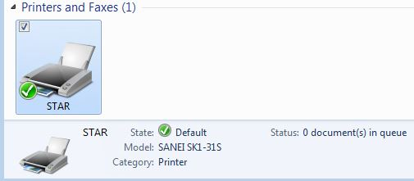

1. **Printer Settings:**

General settings:

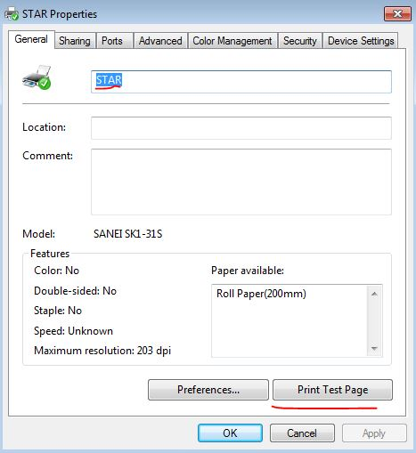Name should be “STAR”

You can test print as well

Ports tab:

“Enable bidirectional support”

Should be off – if it’s on it will show you an exclamation mark in the printer status and the printer will claim there is a paper problem.

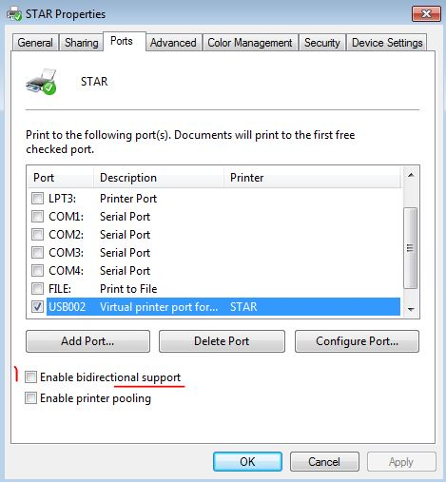

Security tab:

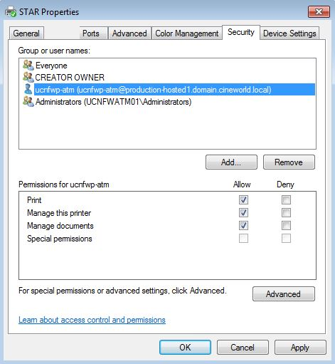Everyone, admin should have all permissions

(Same as in TTP2030)

1. **XML settings**

**VSSCLIENTHARDWARECONFIG**

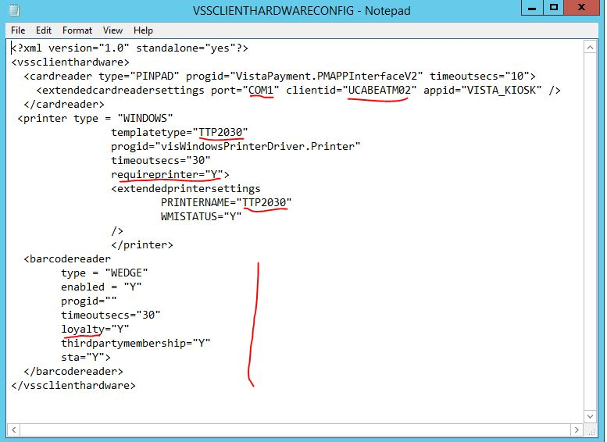**port**=”com1”

This should be the same for most sites

**Client id**

should always be:

UCXXXATMYY where

XXX- site code

YY- ATM number

**Template type** and **Printername**

This depends on printer connected to ATM. In most cases this will either be “STAR” or “TTP2030”

**Requireprinter**: this varies from site to site. If this is “Y” Vista will crash on start when printer will fail initializing

**Barcodereader:** on sites where ATM’s use loyalty, loyalty should be “Y”. if this is set to “N” or there is no string for this ATM’s won’t be able to use loyalty cards/